|  |  |  |
| --- | --- | --- |
| **C++ Programming** | **Student**  **number** | **21300691** |
| **Homework 6** | **Name** | **Cheung, Won Sik** |

1. Problem Definition

I want to make a brick-breaking game. However, I do not have enough time during the semester, so I want to write a ball-bouncing program. If you just bounce the ball is not fun, add another function.

1. Statistics

- number of lines: 485 -> 495

- number of classes: 1

- number of functions: 16

1. Design of my program

* Class Diagram

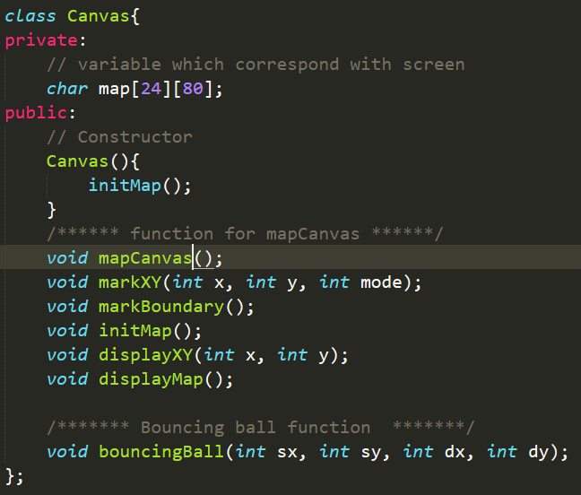

* Flow Chart

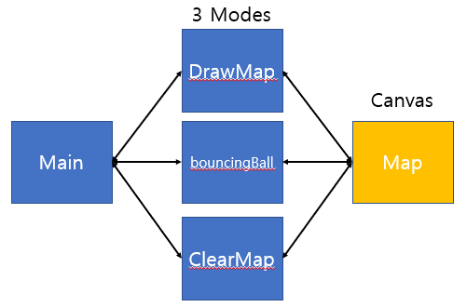

1. Primary codes

* Functions

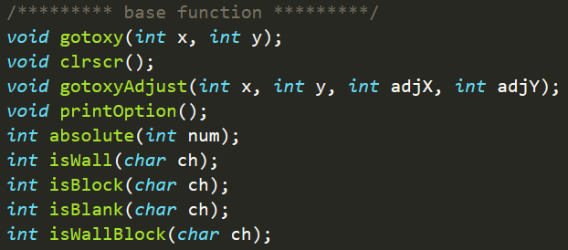

* Main Function-1

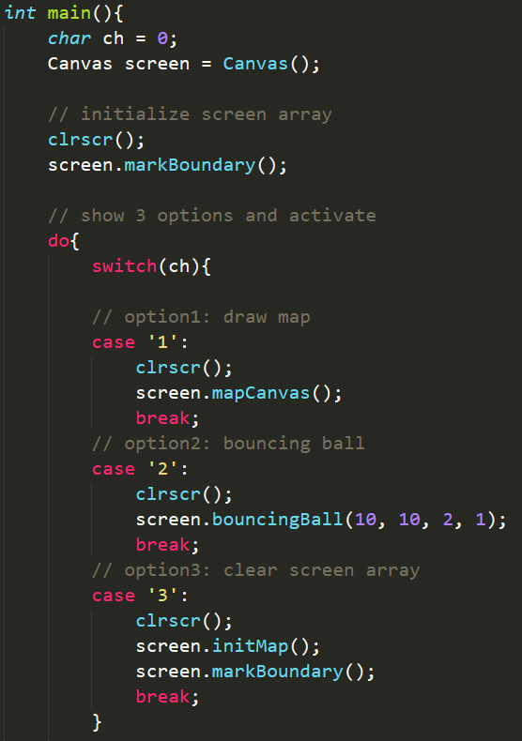

* Main Function-2

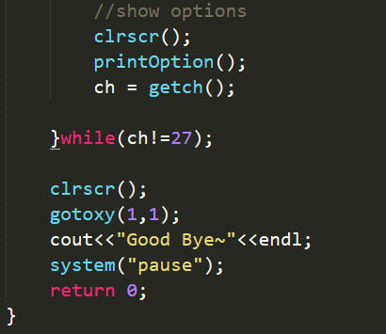

* Movement Functions

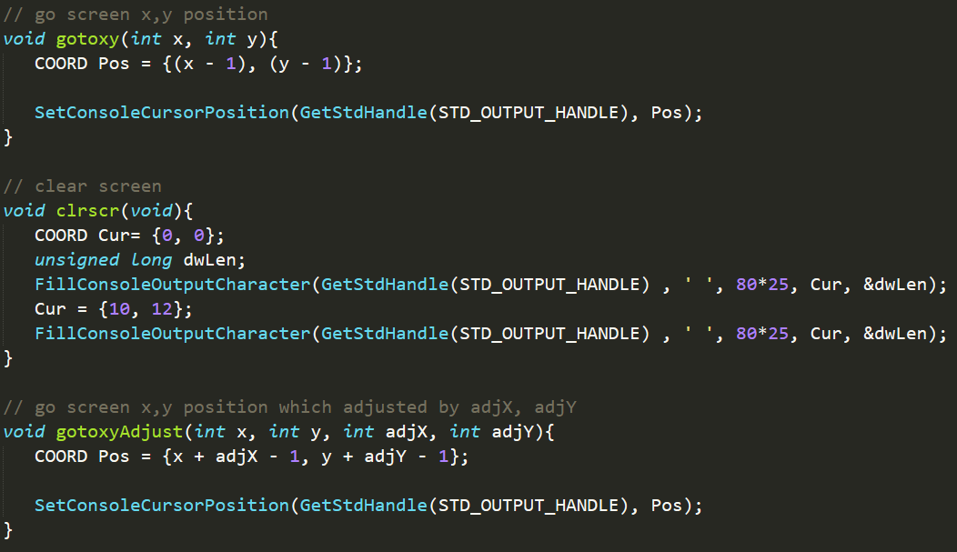

* mapCanvas()

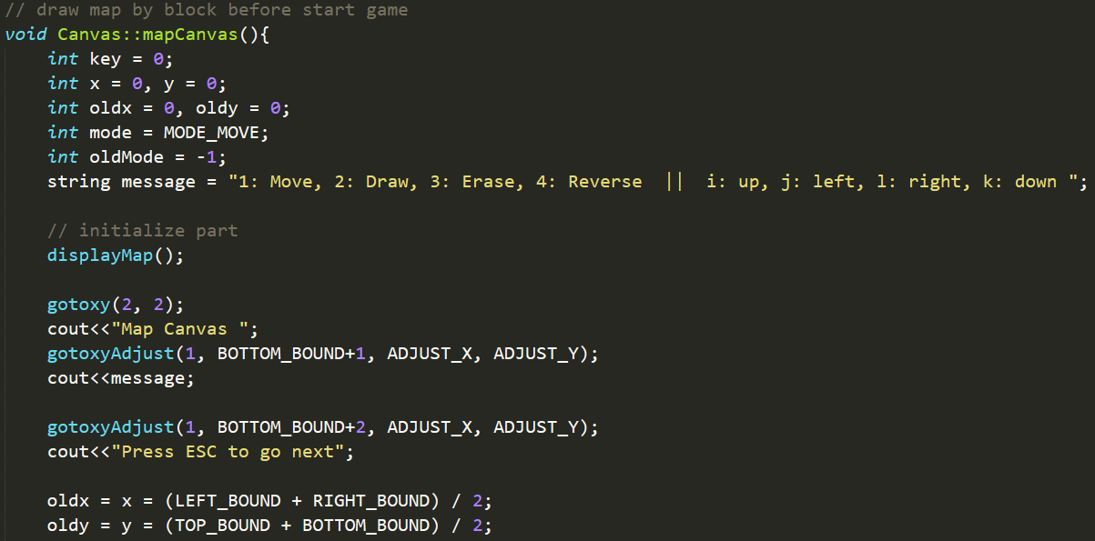

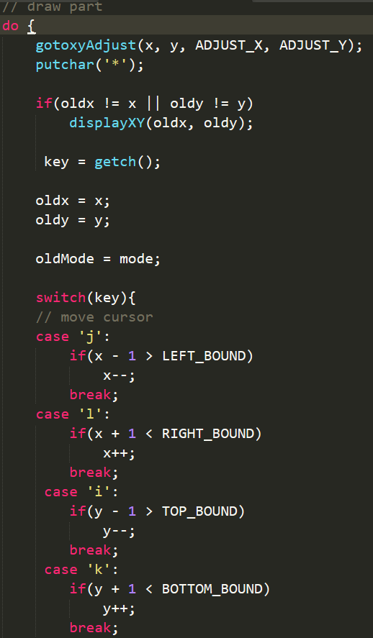

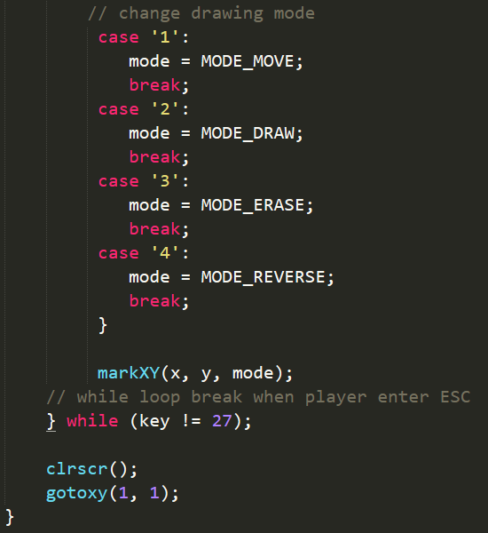

* bouncingBall() -1

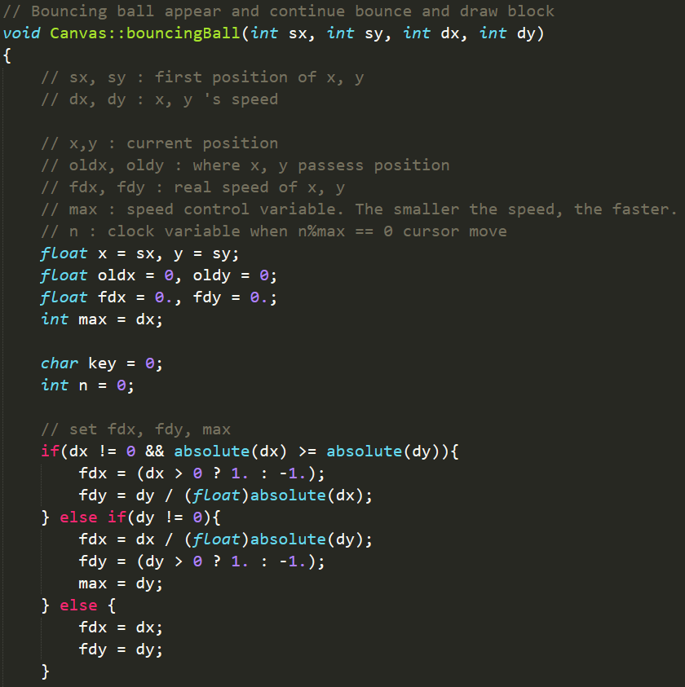

* bouncingBall() -2

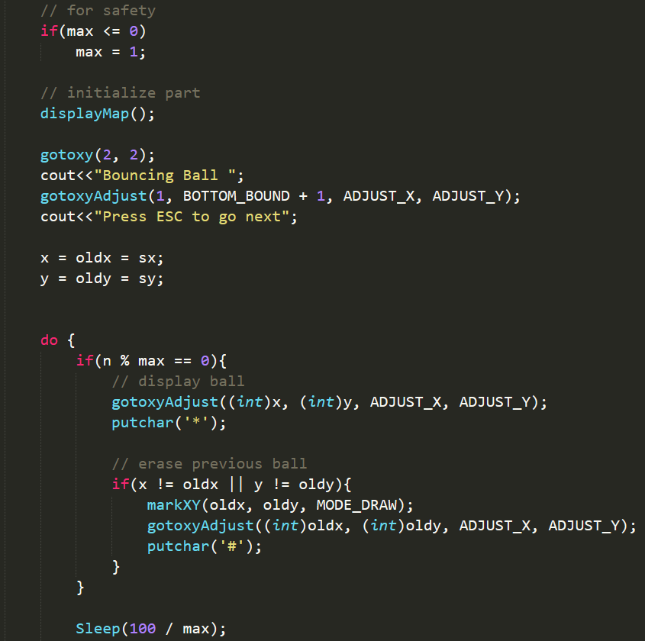

* bouncingBall() -3

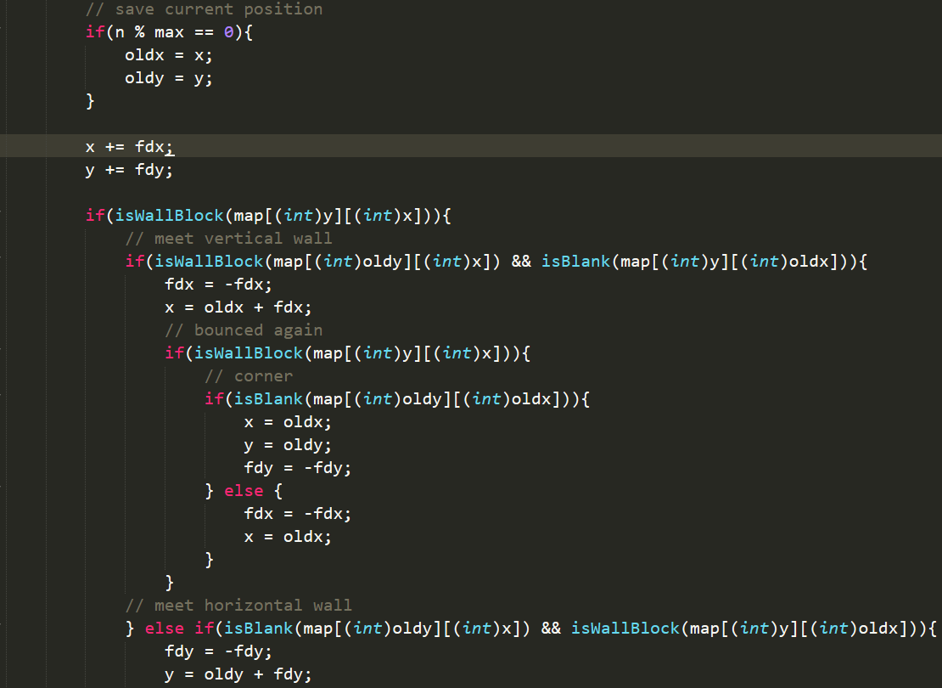

* bouncingBall() -4

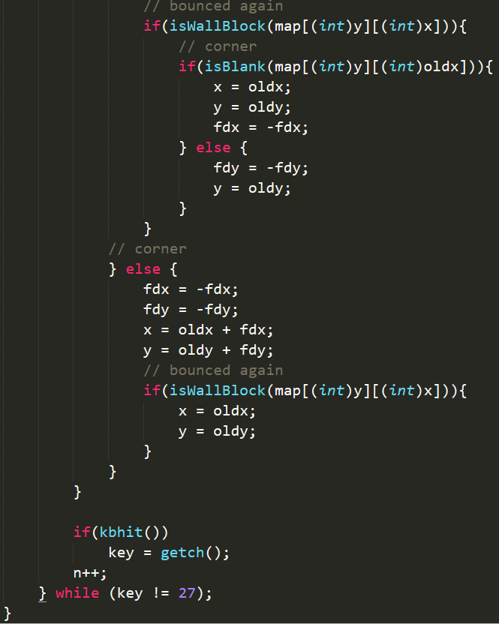

1. Screenshot of the result

* Main Page

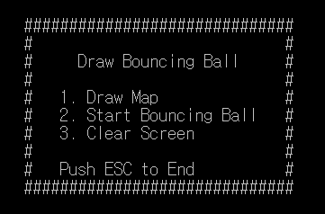

* Draw Map

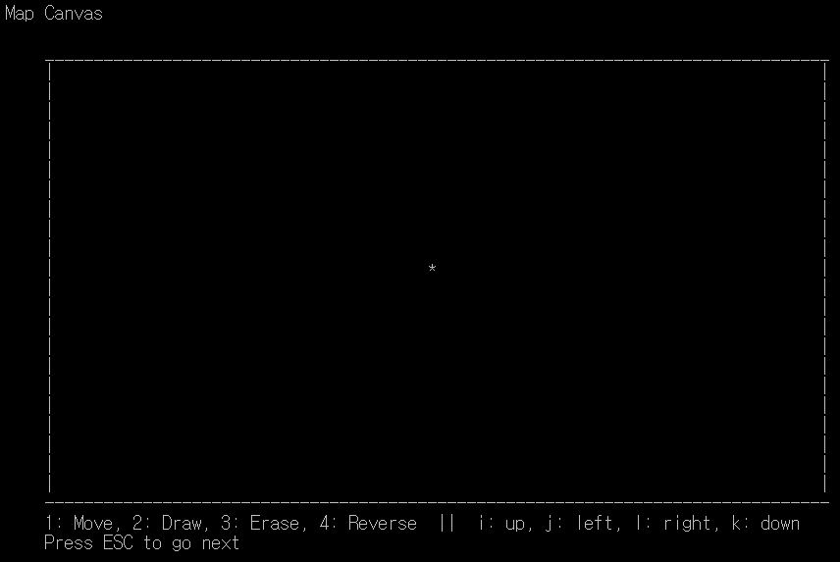

* Draw Map

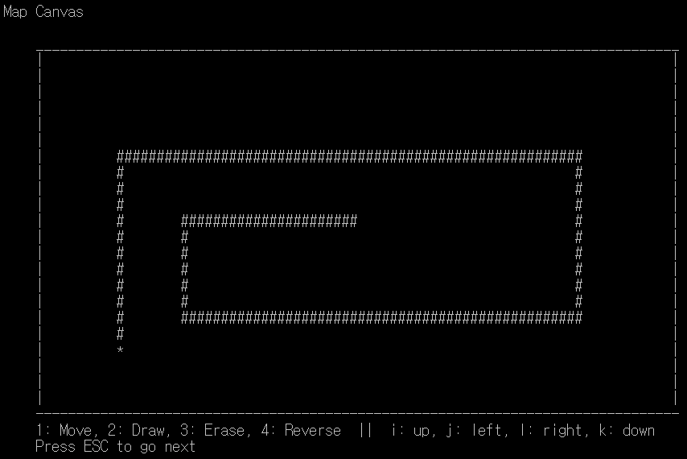

* Bouncing Ball

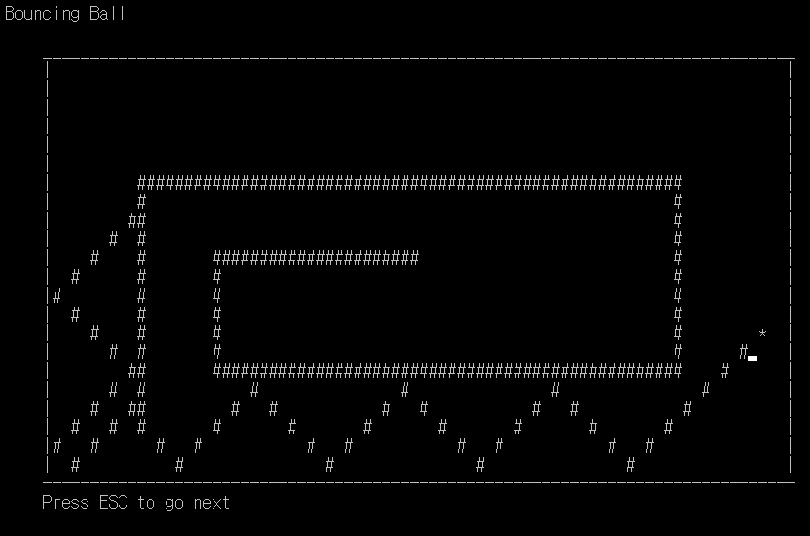

- After Clear Screen

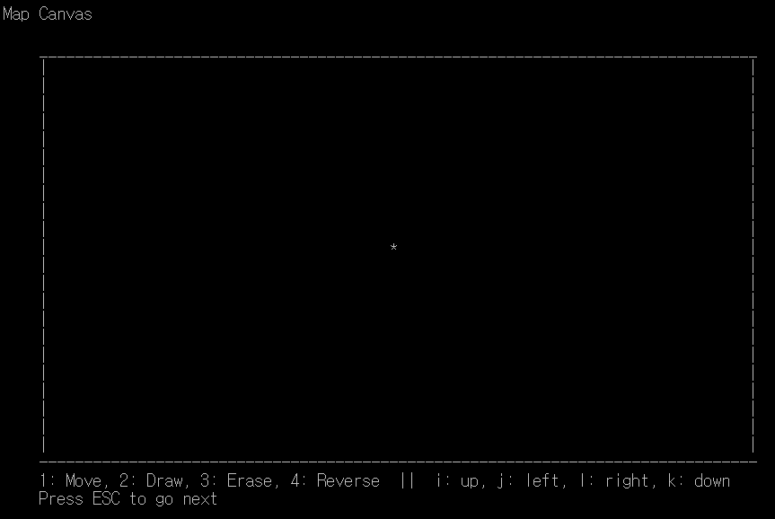

1. Discussion

It was a meaningful time to think about the class. However, the program I created is related to the output of the monitor. So only one object was available and efficiency did not increase. But if you inherit it and add new features (with two balls), I think you can take full advantage of object oriented program.